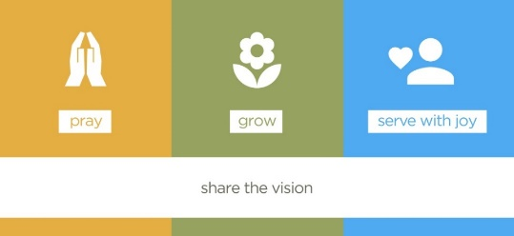
2018 Support Planner: SLA & ‘pay as you use’ services
Name of School / Academy / Federation / MAT

Academic Year 2018 – 2109: Please tick to indicate whether hours required fall within your Service Level Agreement (SLA) allocation, or whether you are purchasing as a ‘pay as you use’ service | Within hours of SLA | ‘Pay as you use’ (non SLA rate) | ‘Pay as you use’ hours (SLA rate)

Support Service Requested | Time (½ day, full day, twilight) | Requested half term for delivery |  |  |  |  |  | Desired outcomes & any preferences for delivery  (specific dates, venue, staff involvement, etc.) | Any Additional Cost  £
 |  | Autumn 1 | Autumn 2 | Spring  1 | Spring  2 | Summer 1 | Summer 2

School Authorised Signature: |  |  | DIOCESAN OFFICE USE ONLY | Total Days |  | Diocesan signature:  Date:
Date: |  |  |  | Total cost if not covered by SLA
Copy to school’s e-file

