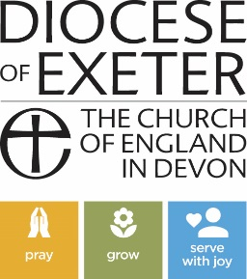

What do Deanery Synod Members Do?

A deanery is a group of parishes within an archdeaconry. Each parish is allocated a number of places for lay people on the deanery synod based on the size of their electoral roll. Deanery Synod members are elected at the Annual Parochial Church Meeting (APCM) to serve a three-year term.

As a deanery synod member, you will be invited to attend at least two meetings per year:
- to consider and debate issues referred to the deanery synod by diocesan synod
- to develop shared initiatives on ministry and mission
- to encourage cooperation between the parishes
- to share expertise and knowledge between local churches
- to organise deanery events such as pilgrimages or quiet days
- to organise cross-deanery training days and courses

Deanery Synod lay members also elect the deanery’s lay representatives to Diocesan Synod and the Diocese’s members of the house of Laity in the General Synod.

What will I need to do?
- Before each meeting, read the agenda and discuss with your PCC if necessary
- Go to each meeting prepared to contribute, debate and discuss
- Listen to all the views put forward during a debate
- Report back to your PCC on the content of the meeting and any decisions taken so that your parish can be kept informed about items discussed at synod, and kept up to date with deanery initiatives.
- Support and pray for each other.
- Support events and projects as the deanery leadership seek to develop mission and outreach across the deanery

Deanery Synod members are automatically members of their parish’s Parochial Church Council, and so are entitled to attend those meetings as well.

