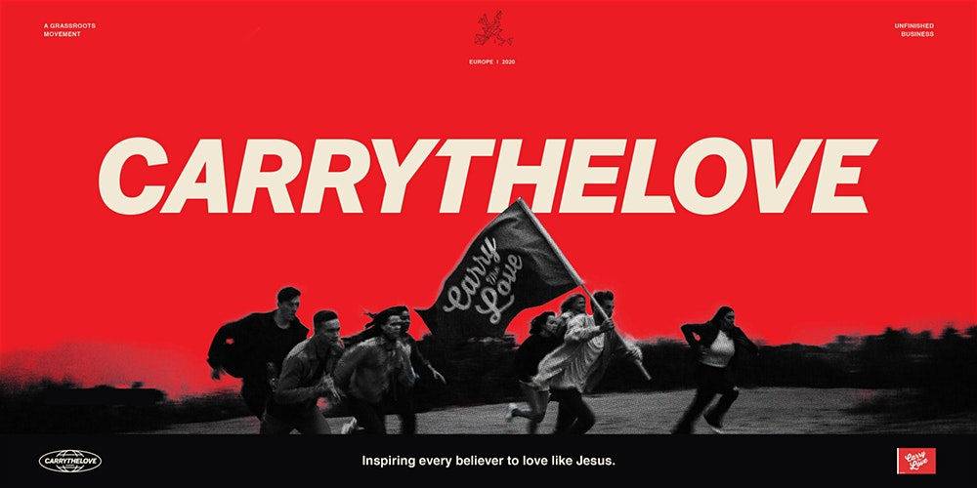We are excited to be hosting the CIRCUIT RIDERS on their 2020 CARRYTHELOVE European Tour.
tinyurl.com/wnsvxaz
Doors 6:30
7:00 to 10:00
St Matthias Church Sunday 16th February 2020
(v.) [kar-ee-the-luv]
In a world filled with hate, division, bullying, anxiety and those things that might stop us from loving ourselves, or others, Jesus invites us to respond with love – his love. The CIRCUIT RIDERS are called to inspire this generation of students to love like Jesus – a love that is infectious, outrageous and life transforming.
Come and hear their music and hear their message at St Matthias, Babbacombe Road, Torquay
- and bring your friends!
Tickets are free and available at EVENTBRITE - tinyurl.com/wnsvxaz - where you can check out some YouTube clips
We are excited to be hosting the CIRCUIT RIDERS on their 2020 CARRYTHELOVE European Tour.
tinyurl.com/wnsvxaz
Doors 6:30
7:00 to 10:00
St Matthias Church Sunday 16th February 2020
(v.) [kar-ee-the-luv]
In a world filled with hate, division, bullying, anxiety and those things that might stop us from loving ourselves, or others, Jesus invites us to respond with love – his love. The CIRCUIT RIDERS are called to inspire this generation of students to love like Jesus – a love that is infectious, outrageous and life transforming.
Come and hear their music and hear their message at St Matthias, Babbacombe Road, Torquay
- and bring your friends!
Tickets are free and available at EVENTBRITE - tinyurl.com/wnsvxaz - where you can check out some YouTube clips

