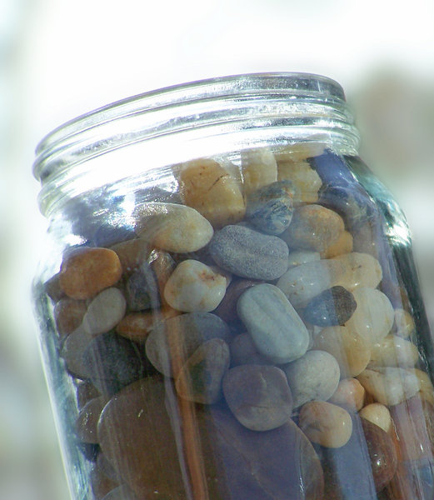
March 2021
A vicar stood before his congregation, he picked up a large empty jar and proceeded to fill it with rocks. He then asked the congregation if the jar was full. They agreed that it was. Therefore, the vicar then picked up a box of pebbles and poured them into the jar. He shook the jar lightly. The pebbles, of course, rolled into the open areas between the rocks. He then asked the congregation again if the jar was full. They agreed it was.
The vicar picked up a box of sand and poured it into the jar. Of course, the sand filled up everything else. "Now," said the vicar, "I want you to recognize that this is
your life. The rocks are the important things - your faith, your hopes, your dreams, your family, health, educations, and the things that bring joy - anything that is so important to you that if it were lost, you would be nearly destroyed. "The pebbles are the other things that matter like your job, your, house, your car. "The sand is everything else. The small stuff.
"If you put the sand into the jar first, there is no room for the pebbles or the rocks. The same goes for your life. If you spend all your energy and time on the small stuff, you will never have room for the things that are important to you. "Take care of the rocks first - the things that really matter."
Lent is a time to reconsider our jar, and how we fill it...the Pandemic too has forced many of us to think about our priorities. As we pray that we are coming to the end of this stage of the virus, let’s get our priorities right as a country, society, communities and as individuals. Priorities I would like to suggest based on kindness, hospitality, welcome, equality and faith. Priorities not about self but about serving others with joy.

Praying for a holy & reflective Lent...
Andrew

