Dear Elector,
Mathew Percy

Deanery: Newton Abbot
Parish: St. Peter, St. Paul and St. Thomas, Bovey Tracey
Age: 43
07546378376
mathewpercyba@gmail.com
5 Long Barton, Kingsteignton, TQ12 3QP

My Identity in Christ
I became a Christian in 1997 during my first year of University in Hertfordshire.
On Easter Sunday in 1999 I was confirmed at Salisbury Cathedral. During this year I became deeply aware of God’s unconditional love and forgiveness, which had a profound effect upon my heart, taking me beyond the fear of the Lord into a beautiful “sonship”.
This new identity empowered me then and empowers me now, to serve the Church and love the Lost.

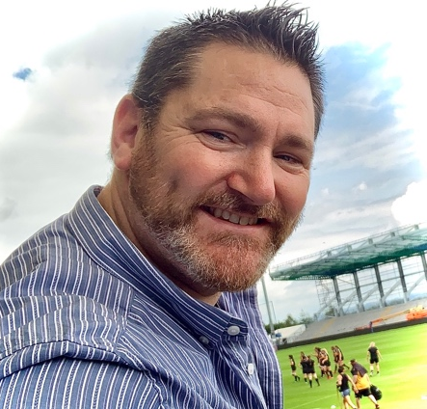
It is my honour to write to you as a candidate in representing our Diocese in the House of Laity at General Synod. I am fully committed to serve, giving my focus and time authentically, dependably and with measured judgement.
I believe that connecting with and to those I would represent is crucial to the process and journey we share as Christians. Therefore, I invite you to contact me to answer questions or concerns on issues close to your heart.
As you consider this statement showing my deep commitment, skills and experience, it is my hope, after your personal reflection, prayer and consultation with other local Christians, that I would have your support as your first preference vote.
Yours in Christ
Mathew
My Life and Career Experience
I have experience across many sectors giving me a wide understanding of the human condition. These include:
- Teaching and education (private, public and special educational needs, as well as home schools)
- Factory and assembly lines
- Life Coaching
- Mental Health
- Marketing
- Retail and Leisure Industries
- Homeless services (drug, alcohol and addictions)
These roles required me to work effectively alongside other professionals such as the Police, medical emergency services, the NHS, Mental Health Specialists, counsellors, educators, enablers and parents. I engaged with the elderly, adults and children, both male and female, to nurture and empower them to flourish.

My Parish Background
As a passionate follower of Christ and a keen student of His word, I am pursuing a BA(Hons) in Theology, Ministry and Mission at St. Mellitus College (Plymouth), with the hope of becoming a vicar in the future.
My wife Tafline and I are remarried divorcees, we have what is called a blended family with three daughters between us, aged seven to thirteen.
We are enthusiastic members of St. Peter, St. Paul and St. Thomas church in Bovey Tracey where I serve as a lay preacher, house-group leader, church service leader and deanery synod representative. I also assist the Vicar in delivering introductory courses to the Christian Faith and courses for new Christians such as Christianity Explored, Alpha and Walking the Way. Tafline is the Church Treasurer and together we serve on the PCC where we have worked to gain an Eco Church bronze award.

Thank you for considering my candidacy
My Perspective of Issues facing General Synod 2021-2026
The needs and lists of concerns facing the CofE is extensive, with each demanding careful reflection, consideration and substantial prayer. I believe that I would be able to apply my experience to good effect in addressing these complex problems, whilst ensuring that the foundations of our Christian faith are retained in our nation’s life.
There remains much to imbue in General Synod’s agenda during the next quinquennium:
- The freedom to preach Christ’s gospel is increasingly opposed by an antagonistic, militant secularism along with government legislation, therefore we need to continue to take advantage of our freedom and defend it.

- There is an urgent need to counter the decline of the church and encourage growth and development through the promotion of family and youth ministries

- Concluding the debate concerning human sexuality, including marriage, same-sex relationships and gender.

- Advancing the Church’s role in environmental and sustainability issues.

- Developing and implementing a theology of Creation Care and thereby making good on our pledge to cut the carbon footprint of the CofE by 2030.*

- Consideration of the Parish system, where there is need to ensure its survival by protecting and promoting its intrinsic value, and reviving, rejuvenating and remodelling the system for the 21st Century.
My Christian Perspective
St. Mellitus College, where I am a student, is an assortment of theologies that gather around a generous orthodoxy. Lectures are accented by strong and colourful debate, seasoned with grace. Therefore, my existing studies give me exposure to current trends and ideas in theology within the CofE, laying a good foundation for debate at General Synod.

General Synod exists to serve the church and enable Christians to carry out the calling and mission given to us by Jesus. Namely, to make disciples of all nations, baptising them in the name of the Father, the Son and the Holy Spirit. Teaching them to obey everything Jesus commanded (Matthew. 28:19-20).

Belief in action is our calling and the General Synod exists to organise and enable this ministry and mission of declaring that belief; the Gospel. Therefore, my effort, time and focus as your representative will be unswervingly referenced by Scripture and a commitment to the historical teachings and catholic Creeds of the Church.

- I will be open and attentive to the voices and concerns of all, balanced with the truth of Scripture.
- I will be actively and appropriately involved in Diocesan affairs, addressing matters of importance locally.
- I will be accountable to you for my performance regarding these commitments and provide reports as and when necessary.

- I will devote the time and effort to fulfil my responsibilities faithfully and knowledgeably.
- I will be steadfast in my role of prayer, not only seeking the Spirit’s direction for the synod but also for you and our diocese in particular.
- I will be accessible to you by phone, email and in person to answer questions and receive input.
*https://www.churchofengland.org/resources/churchcare/net-zero-carbon-church

My Commitment to You
As a lay candidate for the Diocese of Exeter at General Synod, I make the following commitments to you:

