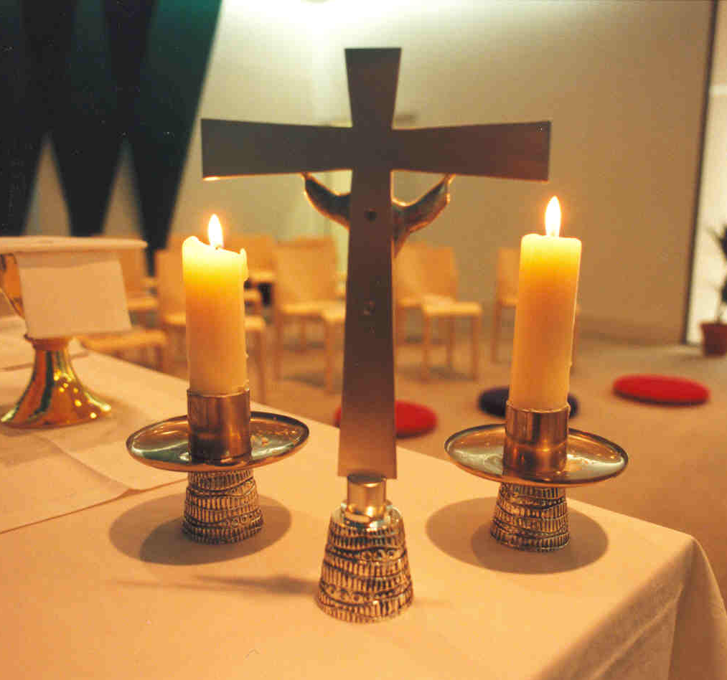
Who may assist with the distribution of Holy Communion?

In many parishes, named lay people assist with the distribution of Communion, either at the communion rail, or in some cases by taking Communion to people in their homes. This is sometimes known as ‘Chalice and Paten permission’ or simply ‘Assisting with Communion’. In some parishes those authorised are called Eucharistic Ministers or Assistants.

The regulations under which this is permitted were changed in 2015 by General Synod and new ones are now in force. There are two main changes:
- in some circumstances, children may now assist in distributing the Sacrament
- authorisation can now be devolved to the parish or benefice, without the need for the Bishop’s direct involvement.

This paper sets out the changes and what parishes need to do if they wish to take advantage of the new regulations. It covers:
- selecting persons to assist
- the PCC’s role
- involving children
- record-keeping
- what a parish needs to do now

INTRODUCTION
The previous Regulations under Canon B.12 required the incumbent and churchwardens to apply to the Suffragan Bishop in writing, giving the names and particulars of the persons to whom the application relates. In practice, in this diocese, the Bishop required the incumbent to indicate that the PCC supported the names being brought forward. The Bishop’s Office maintained a spreadsheet recording the names authorised by the Bishop for every parish.

THE NEW REGULATIONS
The Administration of Communion Regulations 2015 are now in force. The full documentation is available by searching online for ‘GS1992’ and ‘GS 992X’. In brief:
- The Bishop can now devolve his/her authority to an Archdeacon or the incumbent of a parish

- In a cathedral, the Dean is the authority and the Bishop is not involved.

- PCC consent to the names is explicitly required (in a Cathedral, Chapter consent)

- the named persons must be regular communicants

- authorisation is to be given for assisting in the distribution of holy communion within the Eucharist in church or in addition to distribute communion to the housebound.

- whoever gives the authorisations must keep them under review. The simplest way to do this is to require them to be reviewed and renewed every three years
For a child to assist at a service:
- the child must either have been confirmed or have been admitted to Holy Communion under the 2006 regulations for Communion before Confirmation

- in a church school setting i.e. at a school Eucharist, the Head’s consent is required for a particular pupil to assist.

The new Communion Regulations
Procedure for Parishes

1. Selecting persons to assist
This is a sensitive and special form of ministry. It is not intended that anyone can volunteer or be press-ganged just before the service starts. The congregation need to be assured that those who distribute the consecrated bread and wine are in good standing and well-prepared for what they do. For that reason, there must be a list of agreed names for each parish or Mission Community. The incumbent will usually be the right person to put names forward, bearing in mind:
- they must be actual communicants themselves. The Regulations do not require them to be actual members of the Church of England or on the Electoral Roll
- they need to be physically able to undertake the task
- they need to be women and men in good standing and in whom the congregation and clergy have confidence
- as with any pastoral role, a ‘safe recruitment’ process should be observed
- they will need to be trained by the incumbent in the practical and pastoral aspects of the role before commencing
- Authorisation may be granted ‘for the purposes of public worship only’ or ‘to the housebound.
- For those who assist at public worship, and for those who distribute Holy Communion to the housebound, authorisation will in future be delegated to the Incumbent and PCC
- For those people who will take communion to people in their homes there may be safeguarding implications, such as a need to have a clear DBS disclosure. The current advice is that a DBS is not required unless the person is giving other care and support while visiting for home communion, or is visiting weekly or more frequently. If in any doubt, advice must be sought from the Diocesan Safeguarding Adviser.
Note: Readers, as licensed lay ministers do not need to go through this process as they may already assist by virtue of their licence and DBS clearance.
- The PCC’s role
The incumbent should prepare a list of the names and the list should form part of the proposed PCC resolution, circulated with the agenda before a meeting.
The PCC should pass a resolution in these forms:
This PCC, meeting on [date] resolved that [names] , commended by [the incumbent] should be authorised to assist with the distribution of the Holy Communion within Public Worship in accordance with the Administration of Communion Regulations 2015 for a period of 3 years.
This PCC, meeting on [date] requests that [names] , commended by [the incumbent] should be authorised to assist with the distribution of the Holy Communion to the housebound in accordance with the Administration of Communion Regulations 2015 for a period of 3 years
Note: Incumbents and PCCs should be aware that assisting with Communion under these regulations does not permit the persons named to conduct a service of Holy Communion by Extension. This is governed by its own regulations, and such services may only be conducted by a Reader.
It is recommended that after three years those authorised should seek a renewal of this permission.
- Involving children
Involving children in assisting with chalice or paten will not be appropriate in every church, but in parishes with a strong children and young people’s ministry, or with a church school, there may well be situations where the incumbent and PCC would wish to involve them in this way.
Children should be authorised only ‘for public worship’ and not ‘generally’ (for home communions), to minimise safeguarding risks.
In church,
- only children who are on the parish’s list may assist
- unconfirmed children admitted to Communion under the relevant regulations may be put on the list

In a school setting, under these Regulations a pupil in a church school may, with the Head Teacher’s permission and with the assent of the priest, assist in distributing the sacrament at a school Eucharist held in the school or in church.

- Record-keeping

- A record should be kept in the parish office that indicates:
- names of persons being authorised (preferably with their address)
- date on which PCC/Chapter resolution commending them was passed
- date on which authorisation expires

- It would be good practice to publish the list of names in the church magazine, pew sheet or website when they are first authorised.

- To avoid any possible misunderstandings, a notice should be posted in the vestry giving the current list of those authorised to assist.

- Incumbents and priests-in-charge will be asked to complete an annual return of those authorised in their parish church(es), and in church schools in their parishes and to send it back to the Suffragan Bishop’s Office.

- As part of keeping authorisations under review, the record-keeping should be open to inspection by the Rural Dean, and Archdeacons might require it as part of their Visitation process.

- What a parish needs to do now
- The Bishops have decided that in future authorisation for the distribution of Holy Communion in public worship and to the housebound will be delegated to the Incumbent and PCC and will be for three years. .
b) Each PCC should follow the procedure in sections 2-4 in respect of those authorised for (i) public worship (ii) to the housebound.

