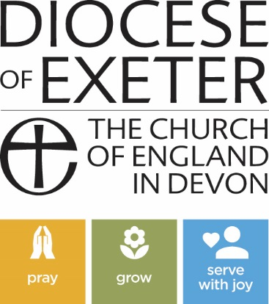
NOTICE OF REVISION OF CHURCH ELECTORAL ROLL

Parish of ...................................................

Notice is given that the Church Electoral Roll of the above parish will be revised by the Parochial Church Council, beginning on the ..... day of ................................... 20........... and ending on the ......... day of .............................20........*

After the revision, a copy of the Roll will be published by the Parochial Church Council [method of publication to be specified here]

…………………………………………………………………………………………………………………………………………
for at least 14 days and a copy of the Roll will be available for inspection on a reasonable request being made to the Council.

Under the Church Representation Rules, a lay person is entitled to have his or her name entered on the roll if the person—
(a) is baptised,
(b) is aged 16 or over, and
(c) has made one of the following three declarations and duly applied for enrolment.

The first declaration is that the person is a member of the Church of England or of a Church in communion with it and is resident in the parish.

The second declaration is that the person is a member of the Church of England or of a Church in communion with it, is not resident in the parish, but has habitually attended public worship in the parish during the preceding six months.

The third declaration is that the person is a member in good standing of a Church which is not in communion with the Church of England but subscribes to the doctrine of the Holy Trinity and is also a member of the Church of England and has habitually attended public worship in the parish during the preceding six months.

Application Forms for enrolment can be obtained from the Church Electoral Roll Officer. In order for a person to be entitled to attend the annual parochial church meeting and to take part in its proceedings, an Application Form for enrolment must be returned by the date shown above for the ending of the revision of the Church Electoral Roll by the
Parochial Church Council.

Any error discovered in the Roll should at once be reported to the Church Electoral Roll Officer.

Dated this **.................. day of ....................................... 20......

Church Electoral Roll Officer

Address..........................................................................................................

Email address (optional)............................................................................

* The revision must be completed at least 15 days, but no more than 28 days, before the Annual Parochial Church Meeting.
**At least 14 days’ notice must be given.

In this Notice, “parish” means an ecclesiastical parish.

