DIOCESE OF EXETER
Grow in Prayer I Make New Disciples I Serve the People of Devon with Joy
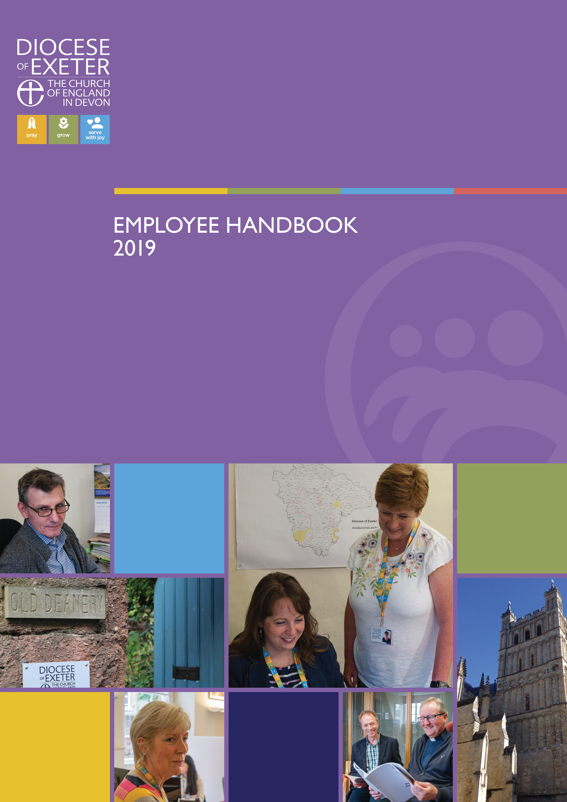
ROLE DESCRIPTION

DETAILS
Role Title | FLOURISH Lead Worker - Plymouth
Department | Education Team
Responsible to | To be confirmed upon appointment
Contract Type | Full time, 3 Year Fixed Term
Hours | 36.25 hours per week (1.0 FTE]
Normal Place of Work | All Saints Church of England Academy, Plymouth and St Pancras Church, Plymouth with travel expected throughout Devon
Responsible for | Developing the FLOURISH worshipping community
Date of Issue | June 2026
NATURE OF WORK
Role Purpose:
FLOURISH is an innovative pilot project which is taking place in schools across the country, seeking to start new, intergenerational worshipping communities within schools. Each FLOURISH project is unique and we are looking for a highly motivated, enthusiastic and committed leader, who will prayerfully and creatively develop & lead the project at All Saints Church of England Academy, Plymouth in connection with St Pancras Church.

The aim of the Pilot Project is to start, develop and lead a new worshipping community at the school, embodying the five core principles underpinning the FLOURISH initiative:
- Ensure that young people’s voices are instinctively at the centre of all leadership decision-making and implementation
- Clearly articulated and shared purpose to grow a younger and more diverse community of Christian disciples
- Strategic leadership partnership between the All Saints Church of England Academy and St Pancras Church
- Develop intergenerational faith experiences involving children, their families and the wider community of all ages
- Develop worship that is fully integrated into the regular rhythms, practices, structures and resources of the school’s vision for ﬂourishing of children and adults

We are seeking to appoint someone to work with the students in All Saints Church of England Academy, involving them in the journey of exploring and discovering faith and of creating a brand-new intergenerational worshipping community.

The new role:
The main aim of the FLOURISH School Lead role is to develop a vision for how a new intergenerational worshipping community can be started within the life of All Saints Church of England Academy and then to establish & lead implementation of the vision and strategy.
This will include:
- Collaborating with school staff, and being available to be involved with the regular pattern of collective worship in the school, and with other opportunities for spiritual development
- Working with children in the school, giving them opportunities to help shape the direction of the new worshipping community as it is established
- Collaborating with All Saints Academy and St Pancras Church, so that new intergenerational worship opportunities can be established, including ensuring this builds on and enhances current provision
- Playing a significant role in the life of the school and church community
- Having the flexibility to work during the school day (for example within existing patterns of Collective Worship and times for spirituality), and outside of school hours including some weekend work
- Furthering links between church, school and home, including through attending community events
- Engaging with national FLOURISH resources and training and opportunities offered by organisations partnering with the national FLOURISH initiative
- Participating proactively in Growing Faith/FLOURISH worker EDBF networks
- Exploring ways to keep the new worshipping community engaged during the school holidays
- Collaborating with the church to explore opportunities for children and their families to continue as members of FLOURISH, or other worshipping opportunities within the church, as children move on from the school
- Collating and submitting project evaluation data, working with the Diocesan and national FLOURISH teams to assess the impact of the pilot, and helping the wider church to learn lessons for future FLOURISH projects and growing faith work.

This role will require to apply for an enhanced DBS check (with barred list) from the Disclosure and Barring Service in connection with this role.

Locations
All Saints Church of England Academy, Plymouth | "I have come that they may have life and have it to the full." John 10:10  At All Saints Academy, our vision is inspired by the words of Jesus and our commitment to providing transformational education that enables every member of our community to flourish. Guided by our values of Love, Legacy and Bravery, we are seeking an exceptional individual to lead and develop our FLOURISH pilot project as we continue to strengthen the distinctive Christian character of our academy.  This is an exciting opportunity to work at the intersection of education, faith, community engagement and social justice, helping young people discover purpose, belonging and hope whilst ensuring that their voices shape the life of our school and wider community.
St Pancras Church | St Pancras is a church centred on loving God, loving church and loving our community. We seek to be a welcoming community of faith, where everyone in our community, of whatever age and background, is able to encounter the love of God for themselves. We are keen to encourage and equip Christians to live their lives Jesus’ way. St Pancras has a long record of working collaboratively with our local schools and community organisations, and we are excited about the way that FLOURISH will enable the wider worshipping community in Pennycross to continue to grow younger and more intergenerational.  Together with All Saints Academy and Exeter Diocese we are seeking to appoint someone who will work with students at All Saints and their families, to enable a new worshipping community at the Academy which will be led and shaped by the young people themselves. This work will be fully supported by St Pancras and will build on the existing work of volunteer chaplains from St Pancras and other nearby churches. We anticipate that the FLOURISH lead will have the initiative and capacity to develop this work.

Role Area
 | Main Duties and Responsibilities
Leadership | Create a worshipping community which:  - Ensure that young people’s voices are instinctively at the centre of all leadership decision-making and implementation  - Clearly articulated and shared purpose to grow a younger and more diverse community of Christian disciples  - Strategic leadership partnership between the All Saints Church of England Academy and St Pancras Church  - Develop intergenerational faith experiences involving children, their families and the wider community of all ages  - Develop worship that is fully integrated into the regular rhythms, practices, structures and resources of the school’s vision for ﬂourishing of children and adults
Strategic Development | - Work with church, school and Diocese to shape a vision and strategy for the FLOURISH community  - Identify routes to secure additional funding for hospitality resources
Policies, Processes and Procedures | - Ensure familiarity and follow church and school policies, processes and procedures  - Contribute to the effective monitoring and evaluation processes and use these to make suggestions for improvements for the FLOURISH work
Information Management | - Maintain confidentiality at all times  - Keep accurate notes, correspondence and records and file with church and school as appropriate  - Ensure information management systems and policies are adhered to, including social media, GDPR and the Data Protection Act (2025)
Team Working | - Work alongside colleagues (internal and external) to ensure that the school, church and FLOURISH community prosper  - Work flexibly ensuring that at all times the needs of the service are respected and prioritised  - Liaise, as required, with Diocesan officers, school leaders and church leaders (incumbents, PCCs, and Archdeacons)  - Undertake other duties as may reasonably be expected  - At all times to work respectfully with colleagues and address any differences of opinion with professional courtesy
Relationship Building | - Maintain excellent relationships between church, school and households by being a key and visible contact  - Enrich links between church and school ensuring the school is a central part of the local and Diocesan mission
Safeguarding | - Ensure safeguarding policies and practices are adhered to  - Undertake school safeguarding level 2 training and church foundation C1 training
Equity and Diversity | - Role model inclusive behaviours in day to day working practices  - Work in accordance with equity, diversity, inclusive and justice policy and practice

PERSON SPECIFICATION
The following areas outline the qualifications, training, experience, and technical abilities beneficial for this role.
 | Essential | Desirable
Qualifications and Training | - A strong and active Christian faith, with a willingness to play an active part in the staff team at both All Saints Academy and St Pancras Church, Plymouth (this post carries a Genuine Occupational Requirement for the postholder to be a committed Christian)  - A minimum of 5 GCSEs grade 9-4 or A-C including maths and English | - Relevant training or qualifications in children’s work, youth work, family support, community engagement, or ministry
Experience | - Experience of working with children, young people, or families from a range of demographics  - Experience of helping young people explore and discover faith  - Experience of working in schools  - Experience of playing a significant role in the life of a church community  - Able to act with initiative and work effectively as part of a wider team across school and church communities  - Demonstrate a clear understanding of the community they will be working in | - Experience of leading or supporting a diverse Christian community
Technical | - Ability to organise and manage a flexible working timetable in partnership with others  - Ability to manage workload and meet deadlines  - Strong communication and interpersonal skills, with the ability to communicate effectively to a diverse audience  - Ability to think creatively and strategically  - Ability to evaluate impact and report to others | - Strong IT skills
General Requirements | - Empathy and understanding of the various needs within the community  - Ability and commitment to collaborative working  - Commitment to best safeguarding practices  - Commitment to ongoing personal and professional development  - Strong verbal and written communication | - Experience in motivating and empowering volunteers  - Awareness of health and safety
Personal Requirements | - Committed to seeing children and young people flourish at all stages of development  - Ability to develop young people’s leadership skills  - Confident in communicating with a diverse range of stakeholders  - Commitment to supporting children and young people as they explore faith and discipleship  - A team player who works well within school and church settings  - A person of integrity and a positive Christian role model within the community | - Proven ability to see a project through from start to implementation

ROLE COMPETENCIES
The following competencies outline the typical strengths, abilities, and behaviours expected to fulfil the role.
Setting Direction | Seeing the Big Picture: | - Shaping and sharing the vision and developing strategy for the creation of a new intergenerational worshipping community  - Understand the nuance of local context and needs of community  - Understand how your work supports the wider objectives of the school, church and diocese  - Stay updated on areas effecting your work and show curiosity and interest in expanding your knowledge
Setting Direction | Changing and Improving: | - Ability to quickly identify current provision within the church and school  - Build on current practice and identify next steps to make the vision a reality  - Respond positively to new situations and change, adopting a proactive approach  - Give and receive feedback, regularly reviewing your work to improve  - Provide creative solutions and overcome barriers to delivery  - Adapt to different working styles of schools, churches and key personnel to facilitate collaboration
Setting Direction | Making Effective Decisions: | - Gather, verify and assess relevant information to understand situations accurately  - Understand the needs of the church, school and households including hopes, reality and challenges  - Active listening and strong communication to aid effective decision making  - Understand the opportunities, constraints and limitations of the role
Engaging People | Leadership: | - Create a welcoming, safe and inclusive worshipping community  - Enthuse others to live out the vision  - Provide opportunities for faith and discipleship exploration  - Role model and promote high standards of practice and behaviour  - Handle sensitive situations sensitively seeking school/church /Diocese leadership support when necessary
Engaging People | Communicating and Influencing: | - Enthuse and empower young people to lead  - Clear communication, including providing regular updates to the Diocese  - Regular meetings with church and school leaders to inform of progress and to agree next steps
Engaging People | Working Together: | - Accept responsibility and accountability for your work, being aware of your actions  - Equity of opportunity for the young people who could be involved  - Collaborate strongly with church and school leadership  - Work independently and as part of a team  - Motivate a volunteer body  - Consider colleagues and your own wellbeing
Delivering Results | Developing Self and Others: | - Engage in agreed Diocesan/national networks and training  - Build strong professional relationships across community  - Support and train young people and volunteers  - Recognise signs of stress in yourself and others and seek appropriate support
Delivering Results | Managing a Quality Service: | - Maintain a can-do attitude, organise your work, prioritise workload, use initiative and be a self-starter  - Strong record keeping and reporting  - Adhere to timetable and deadlines  - Ensure safeguarding, health and safety and GDPR requirements are adhered to  - Follow policies and procedures of school and church  - Be reliable and maintain a consistent approach
Delivering Results | Delivering at Pace | - Manage your time effectively, thinking ahead to make sure that work is completed on schedule  - Stay focused on delivery, ensuring you have the tools and resources needed  - Work calmly under pressure to meet deadlines, handle conflicting priorities and manage resource constraints

