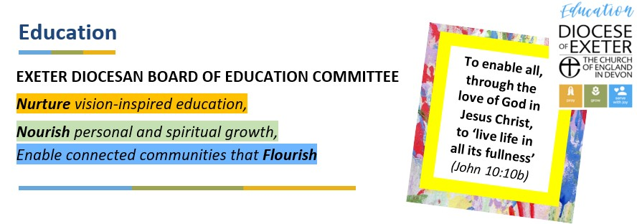
The DBE Committee is the committee of the Diocesan Board of Finance (DBF) established under s.3(7) of the Diocesan Boards of Education Measure 2021 (the 2021 Measure). The DBE Committee exercises the powers and duties conferred on the DBF in its capacity as Diocesan Board of Education (DBE) by or pursuant to the 2021 Measure and which must be delegated to the DBE committee by the DBF (the DBE Functions) in accordance with the Scheme made by the Diocesan Synod on 1st January 2023. At the end of December 2025, the following members had been appointed, elected and co-opted:

The Venerable Douglas Dettmer, Archdeacon of Totnes (Chair)
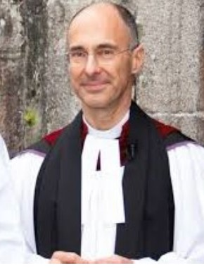
Douglas grew up in Kansas, in the Midwest of the USA.
Having read English at the University of Kansas and Divinity at Yale University, he came to England as curate in the Ilfracombe Team Ministry in North Devon.
Douglas then moved to Exeter as domestic chaplain to Bishop Hewlett Thompson, after which he was for seventeen years a rural parish priest in the Exe Valley, looking after what became the eight Netherexe Parishes.
Douglas has served as Archdeacon of Totnes since 2015, supporting the mission and ministry of the church across central and south Devon.
Douglas is a member of the General Synod of the Church of England and associated commissions and committees.
In the diocese he chairs the Exeter Diocesan Board of Education Committee and the Exeter Diocesan Education Network.
Douglas lives with Chloë in Bovey Tracey on the edge of Dartmoor.

The Bishop of Exeter, the Rt. Rev’d Dr Mike Harrison
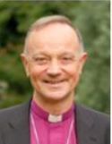
The Rt. Rev’d Dr Mike Harrison is the Bishop of Exeter. He was welcomed into his role at the Diocesan Bishop of Exeter in November 2024. Mike studied Mathematics at Cambridge before spending a formative period at St. Paul’s Church Deptford in London exploring different career options; Mike worked as a lay-worker for the church, as a management consultant in the city and as an unqualified social worker for Lewisham Borough Social Services. Following a decision to test an ordained vocation, Mike trained at Ripon College, Cuddesdon and then at Union Theological Seminary, New York (where he studied the relationship between psychotherapy and theology).

Mike served his curacy in the inner-city London parish of St Anne & All Saints, South Lambeth. During this time he also studied for a PhD in Christian doctrine at Kings’ College, London. Mike then served as Chaplain to the University of Bradford and Bradford & Ilkley Community College. From 1998 until 2006 Mike was vicar of Holy Trinity, Eltham, set in suburban South London, seeing particular growth among children and families. From 2006 to 2015 Mike was Director of Mission and Ministry in Leicester Diocese and, with colleagues, developed a wide variety of training and development opportunities for clergy and laity, as well as fostering a coaching culture and piloting diverse mission experiments. In 2016, Mike became Suffragan Bishop of Dunwich in the Diocese of St Edmundsbury and Ipswich with a keen focus on mission and evangelism, discipleship, engaging children and young people and cultivating vocations. He was also chair of the DBE. Mike took up his present role as Bishop of Exeter on 2nd Nov, 2024. Mike also has a national responsibility for Pioneer Ministry, represents the Church of England on the national Fresh Expressions Board and is one of the Bishops’ champions for the mixed ecology. He is also the Bishop on the Ethical Investment Advisory Group, advising National Church Institutions on ethical investments.

Mike is married to Rachel, an Occupational Therapist and they are blessed with four children aged 22-30. He supports Bolton Wanderers and other lost causes as well as being a bee-keeper and baker of cakes.

The Bishop of Crediton, the Rt. Rev’d Moira Astin
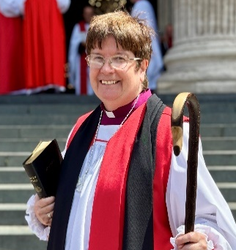
The Rt. Rev’d Moira Astin is the Bishop of Crediton. She was consecrated as the Bishop of Crediton and welcomed into her role in July 2025.
Bishop Moira grew up in Staines, Surrey. She went to Clare College, Cambridge, where she studied Natural Sciences specialising in Geology. After some years working in computing, she went to Wycliffe Hall, Oxford, to train for ordained ministry. Her curacy was in the Diocese of Oxford, which was followed by becoming a Team Vicar for five years in Thatcham. She was then Vicar of St James in Woodley near Reading, before moving to North Lincolnshire where she served as Vicar of Frodingham and New Brumby, in the heart of Scunthorpe, and as Area Dean of North Lincolnshire. Prior to her role as the Bishop of Crediton, Bishop Moira was the Archdeacon of Reigate in Southwark Diocese, a role which she held for nine years.
Bishop Moira has been involved in school governance for over 20 years. She chaired the local governing body for a CofE primary school in Surry as it improved from a series of poor OFSTED inspections to good.
She was the Chair of the Faith and Life Committee of the Ecumenical Secondary School St. Bede’s in Redhill, and before this chaired the Academy Board of St. Lawrence Academy in Scunthorpe.
Bishop Moira is married to her husband Timothy, and they have one son.
She is very fond of seabirds, especially puffins, and she loves to sing.

Deborah Eveleigh
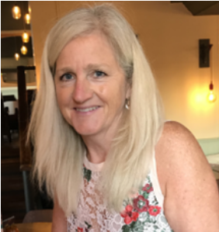
Deborah Eveleigh is passionate about the role of the church in our lives, especially in the education of our children, families and communities.

Deborah has now retired after over 30 years’ practical experience in the education sector holding a range of roles from teacher, SENDCO, Head Teacher, Mentor, to 14 years of Executive Headship. This experience includes the challenges felt by schools, often battling with balancing the very real needs of the pupils, families and communities with other constraints such as budget, HR issues, standards, legislation and inspection frameworks of SIAMS and Ofsted.

To further develop my skills, Deborah gained an M. Ed and the NPQEL qualification and worked in many coaching contexts. In these roles, and through her own schools’ journeys, she has developed her knowledge and experience enabling her to have the opportunity to explore the many arrangements that schools organise themselves and manage their establishments.

Deborah believes that we can all make a positive difference and so, in a voluntary capacity, she is the Chair of the Diocese Schools Organisation and Governance Group, (SOGG), a member of their EDEN (Exeter Diocesan Education Network) committee and also currently an EDEN director. She is also an EDEN representative member for IVY Education Trust and TEAM.

Alex Walmsley
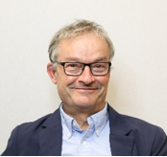
Alex is a retired chartered accountant and was in his working life the managing partner of an accountancy practice with overall responsibility for ensuring clarity of vision and strategic direction and that the firms business aims were achieved. This involved acting as an advisor or non-executive director to a wide range of client companies. Alex has experience of audit, business planning, mergers, acquisitions, and reconstructions.
Alex is a Foundation Trustee and chair of The First Federation Trust and has led on the growth of the Trust from 6 to currently 19 primary schools, developing organizational and governance structures and systems to manage that growth. They are a strongly committed church school trust with 5 VA and 6 VC primary schools across two diocese and Alex sees the maintenance of that strong diocesan connection as a key part of his role.
Alex is also a Foundation Trustee and Chair of Finance and Resources Committee at The Ted Wragg Trust. Ted Wragg is a large MAT comprising 12 secondary schools (including 2 church schools), 3 primary schools and 2 all through school. His role includes ensuring financial and operational systems develop to facilitate the successful growth of the Trust.
Alex is a director of Devon Association of Governance, vice chair of Devon Education Forum and a member of Devon Schools Finance Group. He currently leads the Department for Education’s South West Trust Chairs’ Learning Set for Devon and Torbay.
Whilst his background is in financial management and his particular experience is with financial and budgetary management and governance structures in multi academy trusts, Alex has gained broad experience across the education sector including oversight of operations as well as school improvement and educational performance.
Alex joined the Diocesan Board of Education Committee because he wanted to use his governance experience in high performing trusts to support the Diocesan church school offer.

The Reverend Laura Selman
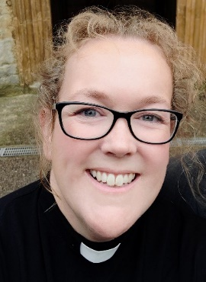
The Reverend Laura Selman is a Team Vicar in the Sid Valley Mission Community with responsibility for 3 churches. She is passionate about the mutual benefits and good relationships between churches and schools for their communities, particularly young people and their families. Laura finds supporting the local CofE Primary school thought-provoking, fun and a huge privilege.
Laura has previously worked with schools in Southwark and Suffolk and has a background in youth work and community development in the UK and South Africa.
Prior to reading Theology Laura studied Politics and Development Studies at Sussex University and spent 7 years working in international advocacy for Tearfund. She worked in public policy and campaigned on climate change and hunger issues, chairing large, cross-sector, multi-faith coalition groups. Laura also co-led a change process which taught her much about the importance not only of what we do, but how we do it. Laura thinks courageous advocacy ought to be a natural outworking of Christian faith and a tool for positive change at every level.

Anna Venables
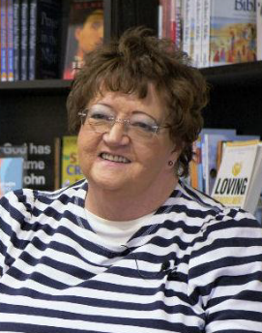
Anna has experience of serving on a Diocesan Board of Education having previously been a member in the Diocese of Derby. She has been involved in schools having served as a governor and on PTAs. Anna is passionate about effective communication and in finding ways to share the good news from schools with others, particularly those within diocesan governance. Anna has served on PCCs (Parochial Parish Councils) and as a parish safeguarding representative. She is currently a Licenced Lay Minister and serves on deanery and diocesan synods.

Employment wise, from school Anna went into the Civil Service as part of the local Department of Health & Social Security, before becoming a mother / housewife. Going back out to work she commenced at Bass Brewing in Burton–on–Trent as a clerical officer, before moving across to a tile manufacturer in the town and then taking on a management role relating to administration and logistics in a sister plastic extrusion manufacturer. More latterly Anna was involved in a company relating to the Petro–Chemical industry. Anna is now retired and enjoys volunteering with the Church.

Dan Polak
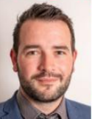
Dan Polak originally trained as a secondary teacher in Southampton, and returned to North Devon, where he grew up, to work as an English teacher before
moving to primary education.

He has worked as a Deputy Headteacher, later a Head of School at a Church school, then as a substantive Headteacher, Executive Headteacher and now Director of Education in TEAM Multi-Academy Trust.

His role is focused on supporting schools to thrive and, in this aim, a school’s Christian distinctiveness is vital to living out the vision of enrichment for all children.

Dan is most passionate about ensuring the voice of rural communities is heard. He cares deeply about supporting schools who find themselves vulnerable through their rurality, which includes many Devon schools.

Matthew Shanks
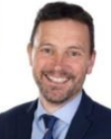
Matthew is currently the Trust Lead of Education South West, a cross-phase multi-academy trust of 15 schools, and Devon Research School, a teaching school hub and an initial teacher training institute. He is motivated by improving cultures and providing opportunities for all children to succeed, not just boosting examination outcomes, and has worked in comprehensive state education for over 30 years at all levels, including a period seconded as Director of Education overseeing strategy for a local authority.

As a National Leader of Education, he has improved outcomes and judgements across primary, AP and secondary schools, and he continues to work in partnership with a number of schools and organisations. Matthew was the chair of the Secondary Headteachers’ Reference Group at the Department for Education, and is a member of the Teaching School Hubs Council, continuing to work with a number of DfE groups.

Matthew is an active trustee for a number of charities and school support networks. He is a foundling trustee of charities ‘Reallyenglish Foundation’ and ‘Leading Great Lives’, and the lead link in the UK for the OECD Ukraine Schools Partnership. He has a long held belief that teachers and leaders should work together across all settings for the good of all communities and young people.

The Reverend Scott Angell
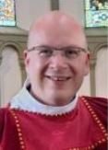
The Reverend Scott Angell is a Curate in the Honiton Mission Community. He serves on the Exeter Diocese Board of Education Committee as the clergy representative, selected by the Diocesan Synod.
As well as his role as a Curate, Scott serves as an ex officio Governor of the Fort Federation, which comprises one VA and one VC primary school.

Scott also serves as a Chaplain for the Honiton Air Cadet, and he is also one of the Diocese of Exeter’s Neurodiversity Champions.

He has a background in Clinical Education, including lecturing and quality management in a further education setting, as well as experience within the NHS.

Jayne Peacock

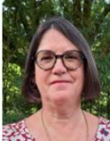
Jayne Peacock is the Executive Headteacher of a group of small rural primary schools in North Devon, two of which are church schools. Throughout her teaching career she has remained deeply committed to the Church of England Vision for Education. Alongside her headship, Jayne has undertaken a range of wider system leadership roles, including serving as a Local Leader of Education, Professional Partner and national adviser on school reorganisation. She has previously trained as an Ofsted Inspector and currently serves as a SIAMS Inspector.

Jayne is passionate about vision-led education that enables children and communities to flourish and to “live life in all its fullness.” She strongly believes that, as a Headteacher, her responsibility extends beyond her own schools to all children within the wider education system. She considers it a privilege to serve on the DBE, SOGG and SEG, and welcomes the opportunity to continue contributing her experience and expertise for the benefit of the wider Church school community.

